Choice 4: Memorial Vocabulary

Here are some words we use to talk about Memorial Day.

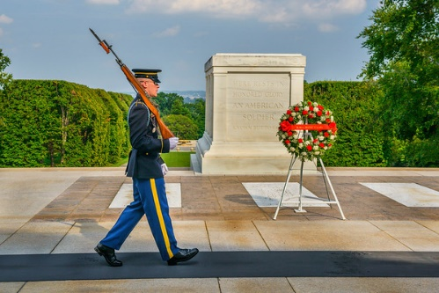The tomb of the unknown solider in Arrlington Cemetary

Can you match the word to the correct picture?

Cemetery dawn flowers grave half-mast

memorial parade veteran wreath

1. 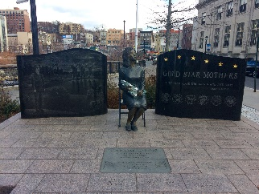 2. 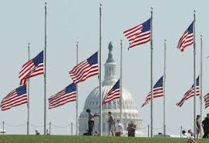 3. 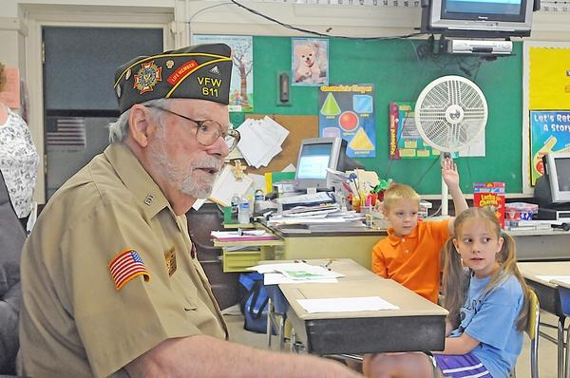

4. 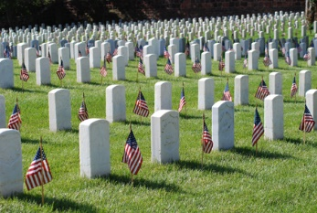 5. 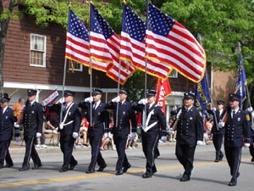 6. 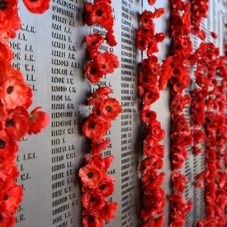

7) 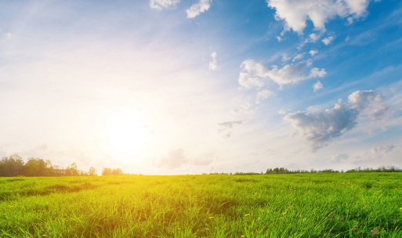 8) 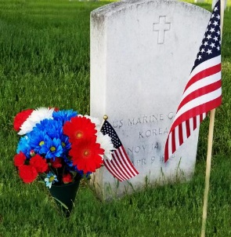 9) 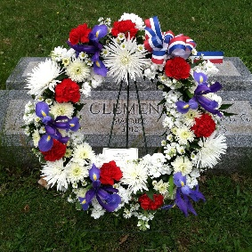

Choose a picture:

* What do you notice in the photo? What do you see in the picture?
* What time of year do you think it is in the photo? What makes you say that?
* What time of day is it? What makes you say that?
* What kind of people/animals do you see? What do they look? What are they doing? Why?
* What else do you see in the picture?